**Set up Cisco AnyConnect Client (if you already have the client then skip to 10)**

1. Navigate to the following URL: [https://login.nmhsc.com](https://login.nmhsc.com/)
2. The user name and password is your domain username and password

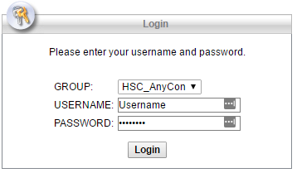

1. Click “Login”
2. On the next page click AnyConnect

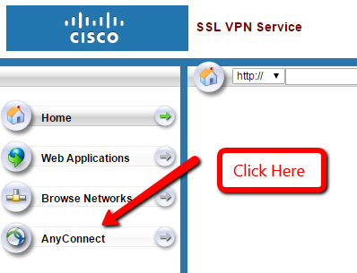

1. Click the AnyConnect Link

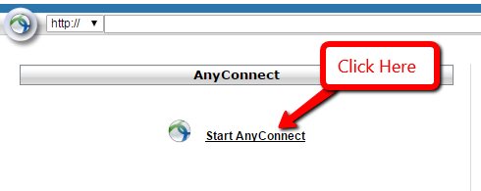

1. The wizard will start and run. If the wizard fails to install automatically and it generally does, click the AnyConnect VPN link.

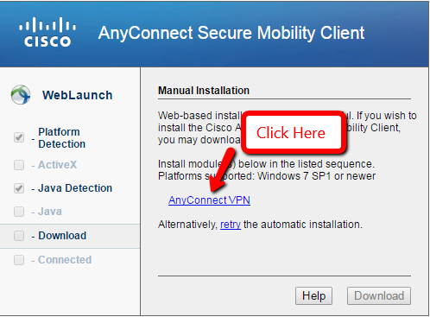

1. The link will download a file for you to install.

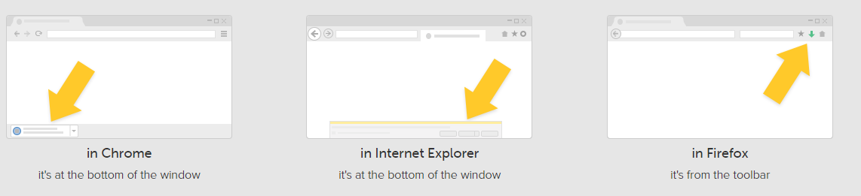

1. Open the file you just downloaded.
   1. Click Run

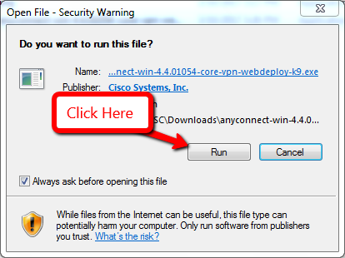

* 1. Click Next

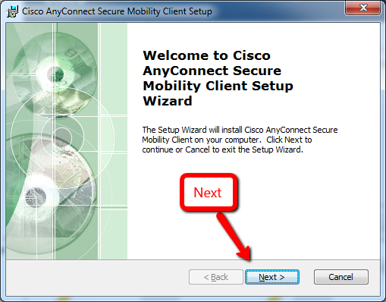

* 1. Choose to Accept the terms and then click next

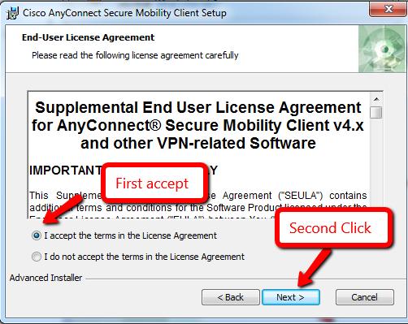

* 1. Click Install

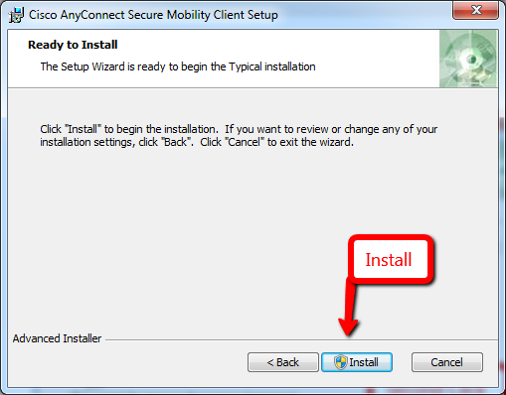

* 1. Wait

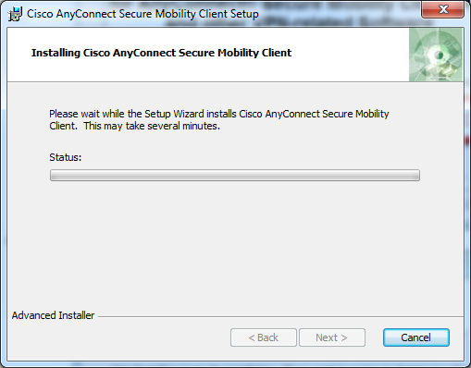

* 1. You may get a warning asking you to continue with the installation click yes.
     1. Windows 7 Version

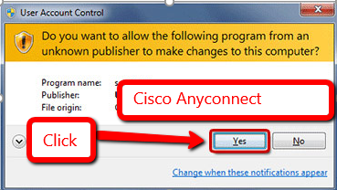

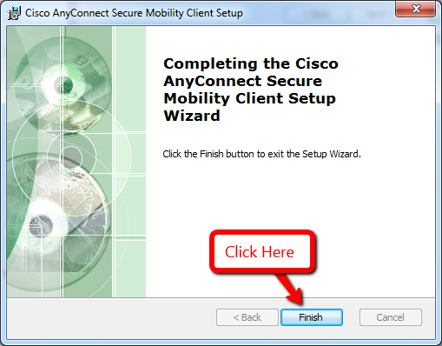

1. Installation is complete
2. Test the installation
   1. Locate Cisco Any Connect in your program list and open it
   2. Change some Preferences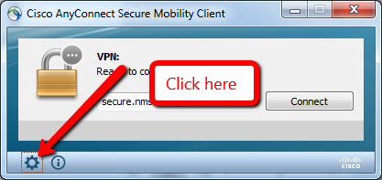

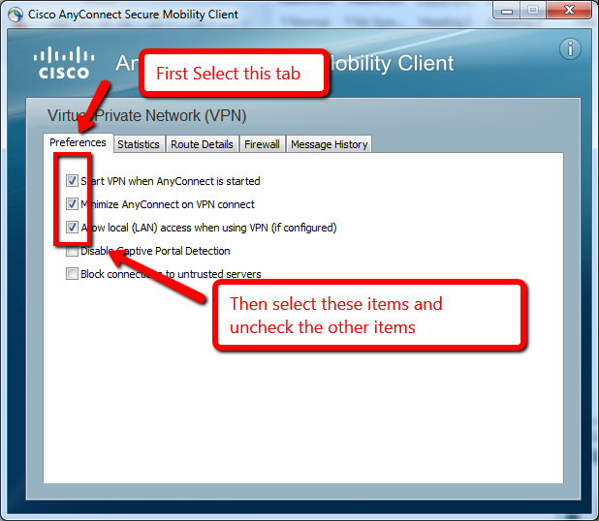

* 1. Enter Secure.Nmhsc.com into the URL box

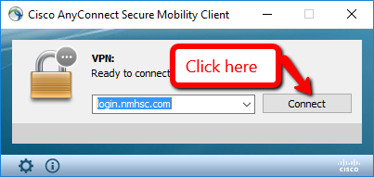

* 1. Enter your domain/username and password for the username and password 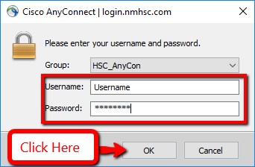

1. You should get a message



1. If you do not connect successfully reboot your machine and try again.
2. If you still do not get in, then send the message log to IT
   1. 